VOLOSHIN, Maximilian Alexandrovich (ВОЛОШИН, Максимилиан Александрович) (1877-1932)

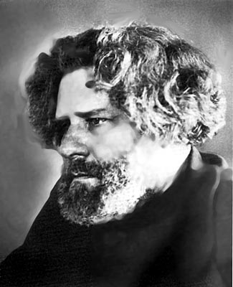
Poet, translator, and literary critic of the late Silver Age and early Soviet era, whose best poems explore philosophical and historical subjects and whose house in Koktebel’ became an important meeting place for poets and intellectuals. Born in Kiev on May 28, 1887. As a child he moved to Moscow with his mother, and later he studied at the Law Faculty at the University of Moscow. He was suspended from the University several times for participating in student-led demonstrations. After dropping out of school, Voloshin traveled extensively through Europe, spending much of his time in Paris. In April of 1906, he married Margarita Sabashnikova who was one of his mentees and a fellow member of the Symbolist literary salons. Their troubled relationship is the topic of many of Voloshin’s poems. By 1911 Voloshin has moved to Koktebel’ in the Crimea where he developed his own literary circle known as the Dacha Circle. During the Russian Civil War, Voloshin served an appointment with the Red Army and acted as a liaison between the Red and the White armies. After legally divorcing Sabashnikova in 1927, Voloshin married his second wife Maria Zabolotskaia. After the Revolution, Voloshin continued to conduct literary circles and was instrumental in founding a Soviet dom otdykha for artists. He died in Koktebel’ on November 8, 1932.

References and Further Reading
Walker, Barbra (2005). Maximilian Voloshin and the Russian Literary Circle. Bloomington, IN: Indiana University Press.

Major Works:

Kimmeriiskie Sumerki (Cimmerian Twilight) [1907]
Anno mundi ardentis. 1915 [1916]
Puti Rossii (The Roads of Russia) [1917-18]
Voznoshcheniia (Ascension) [1917-18]
Protopop Avvakum (Archpriest Avvakum) [1918]

Kristina Syvarth, University of Toronto

Source URL for image:
<http://rolfgross.dreamhosters.com/Tsvetaeva/2-Koktebel.html>

